INT 374
PROJECT REPORT

Andhra Pradesh Tribal Population Analysis and Dashboard Reporting Using Power BI

Submitted by
Venkatesh
Registration No: 12306233
B. Tech CSE - K23DH
Course Code: INT 374

Under the Guidance of
Ms. Sadaf Qureshi (UID: 32988)
DISCIPLINE of CSE/IT
School of Computer Science and Engineering
Lovely Professional University, Phagwara

CERTIFICATE
This is to certify that Venkatesh bearing Registration no. 12306233 has completed INT 374 project titled, “Andhra Pradesh Tribal Population Analysis and Dashboard Reporting Using Power BI” under my guidance and supervision. To the best of my knowledge, the present work is the result of his/her original development, effort and study.
Signature and Name of the Supervisor
Ms. Sadaf Qureshi
School of Computer Science and Engineering
Lovely Professional University
Phagwara, Punjab.
Date: 9-12-25

DECLARATION
I Venkatesh, student of B. Tech CSE - K23DH under CSE Discipline at, Lovely Professional University, Punjab, hereby declare that all the information furnished in this project report is based on my own intensive work and is genuine.
Date: 9-12-25
Signature : Venkatesh
Registration No. 12306233

ACKNOWLEDGEMENT
I would like to express my sincere gratitude to my faculty guide Dr. Sadaf Qureshi for her valuable guidance, support, and encouragement throughout this project. I am thankful to Lovely Professional University for providing the necessary resources and environment for conducting this project successfully. I also extend my appreciation to all those who directly or indirectly contributed to the completion of this report.

TABLE OF CONTENTS

1. Introduction
2. Source of dataset
3. EDA process
4. Analysis on dataset
i. Introduction
ii. General Description
iii. Specific Requirements, functions
iv. Analysis results
v. Visualization
5.Github link/LinkedIn:
6. Conclusion
7. Future scope
8. References.

1. Introduction
The Andhra Pradesh Tribal Population Analysis Dashboard is a comprehensive and insightful analytical tool developed to understand and evaluate demographic patterns, distribution, and socio-economic indicators of tribal communities across the state. The dataset provides a detailed breakdown of tribal population statistics segmented by districts, mandals, gender classifications, and additional demographic attributes. With multi-level granularity, the data enables in-depth exploration of tribal population trends, growth patterns, and regional disparities within Andhra Pradesh.
Key features include:
- District-Wise Population Distribution:
Analyze tribal population figures across all districts to identify regions with the highest concentration, enabling targeted development planning.
- Gender-Based Demographics:
Explore the population split between male and female tribal residents, helping to understand community structure and gender ratios.
- Regional Comparisons:
Study variations in population density and distribution across multiple administrative levels, including rural and semi-urban regions.
- Trend & Growth Analysis:
Examine year-over-year or region-based demographic changes, offering insights into migration patterns, development indicators, and community expansion.

2. Source of Dataset
The dataset used for this analysis was sourced from Censusindia.gov.in, specifically from the dataset titled "Andhra Pradesh Tribal Population Analysis" This dataset contains detailed sales analytics information, including transaction records, product details, and customer data, making it a valuable resource for exploring business trends, customer behavior, and sales performance. It serves as a practical foundation for data analysis projects related to retail and e-commerce analytics.
https://censusindia.gov.in/census.website/data/census-tables?utm_source=chatgpt.com#

3. EDA Process
Exploratory Data Analysis (EDA) is the foundational step in understanding the structure, distribution, and characteristics of the dataset. For the Andhra Pradesh Tribal Population dataset, EDA was essential to clean the raw demographic data, format inconsistencies, and extract meaningful insights at district and regional levels.
The following EDA techniques were used:
• Handling Missing or Inconsistent Data Entries
- The dataset contained several blank cells, merged headers, and irregular formatting.
- Missing values were identified and handled appropriately by removing irrelevant rows (e.g., header repetitions) and imputing or leaving blanks where necessary.
- Inconsistent entries such as mismatched labels and undefined regions were corrected for uniformity.
• Cleaning Column Names and Formatting
- The original dataset contained generic column names such as Unnamed: 1, Unnamed: 2, etc.
- Column headers were standardized to meaningful names such as:
State Code, District Code, District Name, Tribe Code, Tribe Name, Area Type (Rural/Urban), Total Population, Male Population, Female Population.
- Data types were converted to numeric formats for accurate aggregation.
• Aggregating Population Metrics by Region and Tribe
- Total tribal population was aggregated district-wise to identify high-density areas.
- Population counts were grouped by:
  - District
  - Tribe Name
  - Area Type (Rural / Urban)
  - Gender categories
- These summaries helped in understanding demographic concentration and distribution patterns across Andhra Pradesh.
4.Home Page
4.1 Overview
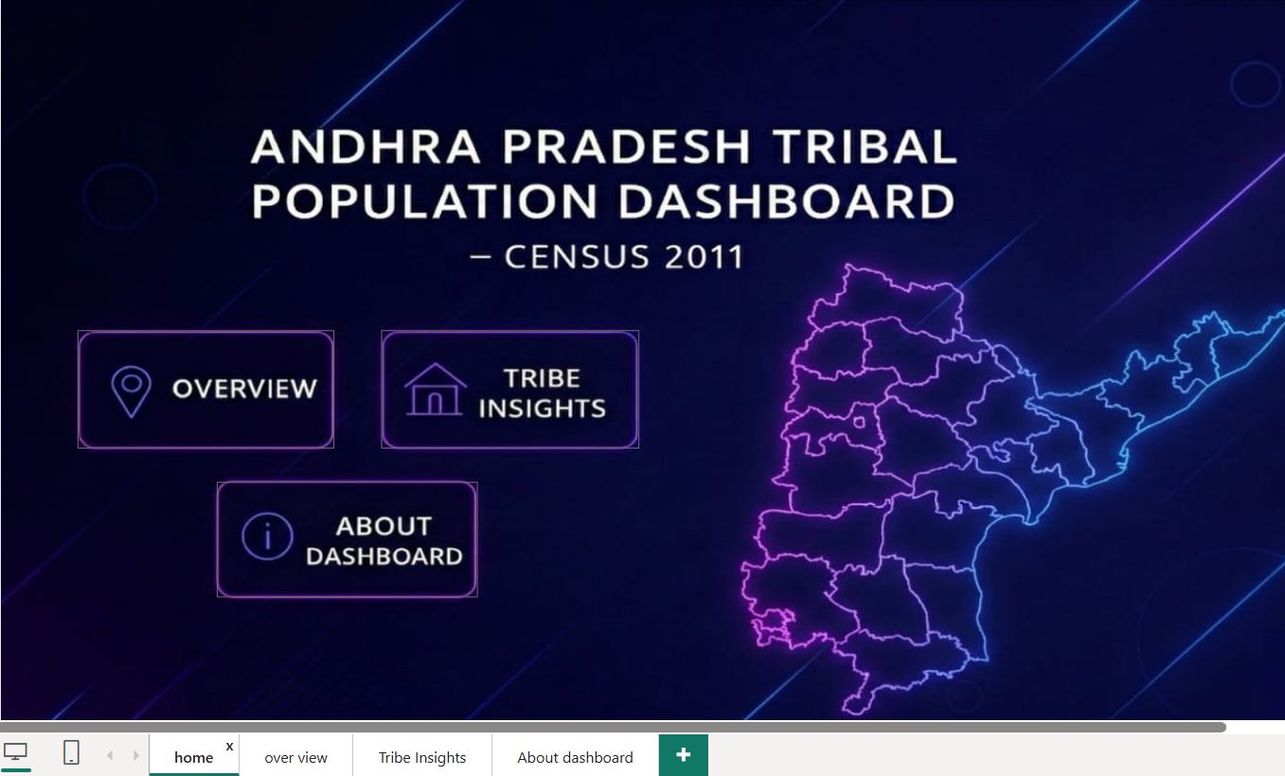
I . Introduction
The Overview section of the Andhra Pradesh Tribal Population Dashboard provides a high-level summary of tribal demographics across the state as per Census 2011. This analysis aims to highlight the overall size, distribution, and characteristics of Scheduled Tribe (ST) populations across districts, enabling a broad understanding of tribal presence and diversity in Andhra Pradesh.
ii. General Description
The Overview dataset includes:
- District-wise tribal population
- Total male and female population
- Urban and rural distribution
- State-level summary of all tribes combined
It helps understand demographic concentration, gender composition, and regional variations of tribal communities.
iii. Specific Requirements, Functions
Requirements:
- Cleaned and structured tribal population data from Census 2011
- Tools such as Power BI for analysis and visualization
iv. Analysis Results
- Identified districts with highest and lowest tribal population
- Calculated gender distribution and identified districts with notable differences
- Analyzed the proportion of rural vs. urban tribal population
- Highlighted key demographic patterns across the state
v. Visualization
Visual elements used:


4.2 Tribe Insights
i. Introduction
The Tribe Insights section provides detailed analysis of individual Scheduled Tribes across Andhra Pradesh. This section identifies the major tribes, their population size, regional concentration, and gender distribution.
ii. General Description
This dataset includes:
- Tribe names and corresponding codes
- Population of each tribe
- District-level distribution
- Male and female counts per tribe
- Urban vs. rural distribution
It provides insights into which tribes are dominant in specific regions and how their demographic patterns vary.
iii. Specific Requirements, Functions
Requirements:
- Tribe-wise population data from the dataset
- Ability to filter population by tribe, area type, and district
- Pivot Tables: Tribe vs. District comparisons
- Charts: Bar charts, treemaps, category-wise comparisons
iv. Analysis Results
- Identified tribes with the largest population share
- Highlighted tribes concentrated in specific districts or regions
- Compared male and female population for each tribe
- Identified tribes predominantly residing in rural vs. urban areas
v. Visualization
Visual elements used:
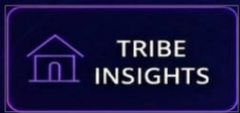

4.3 About Dashboard
i. Introduction
The About Dashboard section provides a descriptive overview of the purpose, structure, and design of the Andhra Pradesh Tribal Population Dashboard. It helps users understand the objective of the project and how to navigate the interactive pages.
ii. General Description
This dashboard is built using Census 2011 data to present:
- District-level demographic information
- Tribe-wise insights
- Gender distribution
- Rural–urban classification
It is designed to support researchers, policymakers, and students in accessing tribal demographic insights quickly and effectively.
iii. Specific Requirements, Functions
Requirements:
- Cleaned dataset from Census 2011
- Power BI for interactive dashboard creation
- Data modeling
Concepts Used:
- Power Query: Data cleaning and shaping
- DAX: For measures like total population, gender ratio, and tribe-wise aggregates
- Relationships: Linking district, tribe, and population tables
v. Visualization

4.2 OVERVIEW
i. Introduction
The Andhra Pradesh Tribal Population Analysis Dashboard is an interactive and visually compelling tool designed to explore demographic patterns across various districts of Andhra Pradesh. Built using Power BI, the dashboard provides a comprehensive overview of the total tribal population, including gender-wise distribution and district-level variations. By consolidating population metrics into a unified visual platform, the dashboard enables users to understand demographic trends, identify high- and low-population regions, and support data-driven decision-making for community development and resource allocation.
The dataset includes attributes such as total population, male population, female population, and district names, allowing detailed segmentation and comparison across the state. Through a combination of charts, gauges, and comparative visuals, the dashboard highlights distribution differences and demographic imbalances, making it a valuable resource for policy planning, research, and social welfare analysis.
Key Features of the Dashboard Include:
- Total Population Overview:
A dynamic gauge visual that displays the overall tribal population across the state.
- District-wise Distribution:
A donut chart summarizing how the tribal population is spread across all districts, enabling quick identification of densely and sparsely populated areas.
- Gender-wise Comparison:
Separate visuals representing the total male and female tribal population, helping analyze gender distribution patterns.
- Male vs Female Breakdown:
A bar chart comparing male and female counts side-by-side for better understanding of population balance.
- Top/Bottom Districts by Population:
A sorted bar graph showcasing districts with the highest and lowest population figures, supporting deeper demographic insights.

v. Visualization
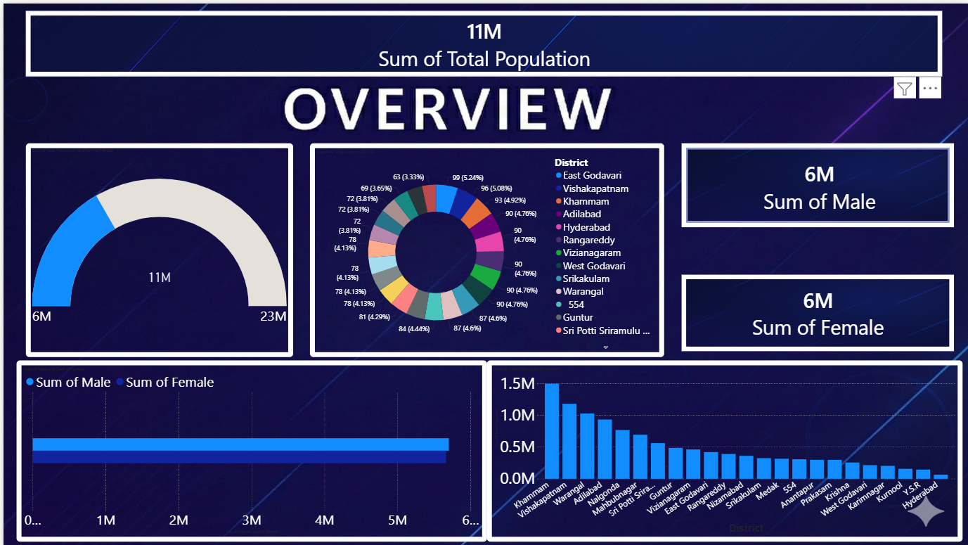
4.3 Tribe Insights
i. Introduction
The Tribe Insights Dashboard is an analytical and interactive visualization tool designed to explore the demographic distribution of various tribal communities across Andhra Pradesh. This dashboard provides a comprehensive understanding of tribal population patterns by presenting data across settlement types, tribal groups, and geographic regions. It enables users to analyze how tribal populations are distributed between rural and urban areas, while also highlighting the relative size and presence of different tribes within the state.
By combining bar charts, tree maps, and district filters, the dashboard offers a clear and intuitive way to understand population concentration, community diversity, and regional variations. These insights help researchers, policymakers, and social welfare departments to identify key tribal groups, plan targeted developmental programs, and allocate resources efficiently.
Key Features of the Dashboard Include:
- Rural–Urban Distribution:
A comparative bar chart showing how tribal populations are spread across rural and urban regions, helping identify settlement dominance and urbanization patterns.
- Tribal Group Composition:
A tree map visualizing the major scheduled tribes of Andhra Pradesh, showing population share and enabling quick comparison of larger and smaller communities.
- District-Level Filtering:
A slicer enabling users to explore tribal population insights by district, supporting localized analysis and better understanding of community densities.
This dashboard provides a meaningful and data-driven view of Andhra Pradesh’s tribal communities, supporting informed decision-making, socio-economic planning, and research on population diversity.
v. Visualization
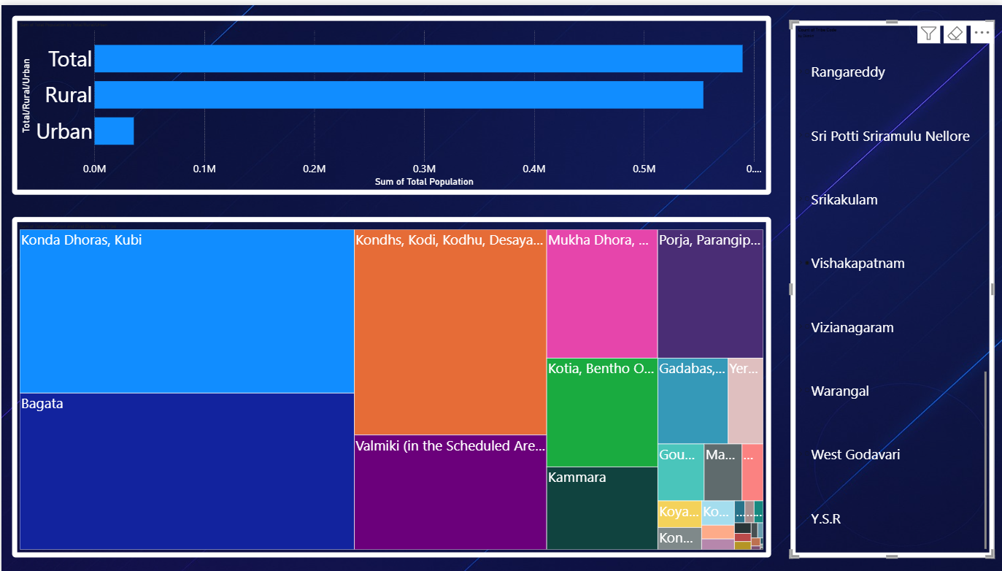

4.4 About Dashboard
i. Introduction
The analysis highlights how the Scheduled Tribe population varies significantly across districts in Andhra Pradesh. Each district shows different patterns in total population, gender distribution, and the dominance of specific tribal communities. While most districts have a slightly higher male population, the gender ratio differs from region to region. The tribe-wise visuals also reveal which tribes are more prominent in each district, helping us understand the cultural diversity of the state. Overall, the dashboard provides useful insights into population distribution, gender balance, and tribal composition, supporting better planning and decision-making.
v. Visualization
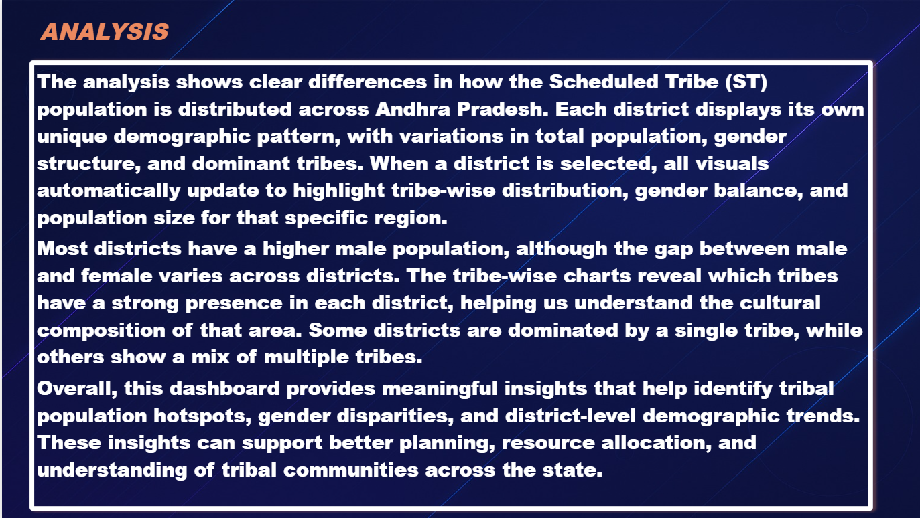

5.GitHub Link and Linkedin
a)Github
https://github.com/venkatesh-2005/Excel-Dashboard
b)LinkedIn
https://www.linkedin.com/posts/venkatesh-v5_powerbi-dashboarddesign-tribalpopulation-activity-7403877364704935936-dLhs?utm_source=social_share_send&utm_medium=member_desktop_web&rcm=ACoAAEMMlBkBwPMXlLJmMMhAN15VPYz9Xy3aKg4
6. Conclusion
The Andhra Pradesh Tribal Population Analysis provides a comprehensive overview of how Scheduled Tribe (ST) communities are distributed across the state. Through interactive Power BI visualizations, the dashboard highlights key demographic patterns, including total population size, rural–urban distribution, gender balance, and tribe-wise representation. The district-level insights reveal significant variations in population concentration and cultural composition, with some districts showing dominance of specific tribes while others reflect a more diverse mix. These findings help in understanding the socio-demographic landscape of tribal communities and can support policymakers, researchers, and development authorities in planning targeted welfare programs, improving resource allocation, and promoting inclusive growth. Overall, the project offers a meaningful and data-driven foundation for enhancing the well-being and development of tribal populations in Andhra Pradesh.

7. Future Scope
This analysis can be further expanded by integrating additional datasets such as literacy rates, employment levels, health indicators, and socioeconomic conditions of tribal communities across Andhra Pradesh. Incorporating time-series data would help track demographic changes over the years and identify emerging trends. Advanced analytics, including predictive modeling and geospatial mapping, can also be added to support more accurate planning and decision-making. Future enhancements could include an interactive mobile-friendly dashboard and integration with government datasets to provide real-time insights for policy development and welfare initiatives.
8. References
[1] Census.Gov.In : https://censusindia.gov.in/census.website/data/census-tables?utm_source=chatgpt.com#
[2]YouTube link : https://www.youtube.com/watch?v=MMdcczmULrU&list=PLmejDGrsgFyBsZlhRBdJQb9dQWQTTYPdC&index=3

